Ch. 21 Lynching in the Jim Crow Era

Answer each question thoroughly. {Instructors: insert specific directions such as word count, response type, submission format, etc.}

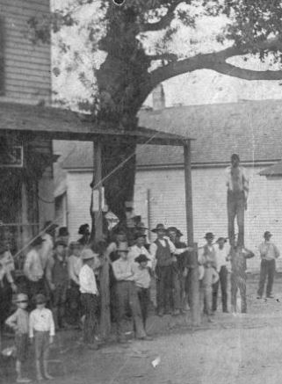

Image 1. “The lynching of a man from the Hanging Tree in Orange, Texas. 1888.” Source: https://picryl.com/media/detail-hanging-tree-lynching-orange-texas-1888-cropped-0b64bc
The Portal to Texas History. Copyright: Public Domain.

- BACKGROUND
- Read: https://dictionary.cambridge.org/dictionary/english/vigilantism
- Answer: Define vigilantism?

- INTERPRET
a. View: Study the image above
b. Answer: Does vigilantism seem to be reflected? Why or why not?

3. CONSIDER
a. Read:
https://www.americanyawp.com/reader/18-industrial-america/ida-
b-wells-barnett-lynch-law-in-america-1900/
b. Answer: What are some justifications given by Wells for the lynching of blacks? How does she specifically point out the hypocrisy of those reasons?

4. CONNECT
a. Read: Ahmaud Arbery Shooting: A Timeline of the Case in the NY Times
b. Answer: Is there an historic thread of vigilantism in American history that connects this event to those of parts 3 to part 4 of the discussion prompt, in your opinion? Why or why not?

