Chapter 21 – Progressivism
Christopher Gerdes, M.A.I.S.
Christopher.gerdes@hccs.edu

Directions: Follow each prompt. You will read a selection and/or view an image/document. Answer each question thoroughly. {Instructors: insert specific directions such as word count, response type, submission format, etc.}
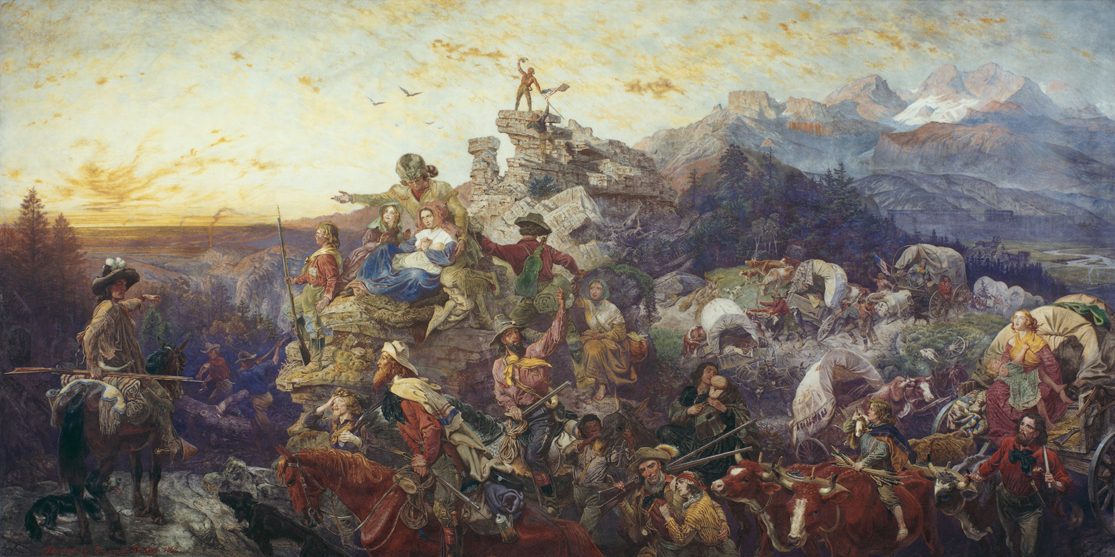
Image 1: “Westward The Course of Empire Takes It’s Way” by Emanuel Luetze. Copyright 1861, Smithsonian. Source link: https://americanart.si.edu/. Public Domain.

- BACKGROUND
  - Read: https://openstax.org/books/us-history/pages/17-1-the-westward-spirit in the OpenStax US History textbook.
  - Answer: Based on the reading describe the essence of Manifest Destiny in your own
words.

- CONSIDER
  - View: Look at the image above.
  - Answer; How does the image above reflect your response to part one?

- REFLECT
  - Read: https://openstax.org/books/us-history/pages/17-2-homesteading-dreams-and-realities
  - Answer: What practical challenges did the men and women who moved westward to start their new lives face? What role did these challenges play in creating a unique American mindset?

- CONNECT
- Read: https://blogs.lse.ac.uk/usappblog/2016/03/04/donald-trumps-calls-to-make-america-great-again-show-that-american-exceptionalism-is-still-a-powerful-idea/
- Answer: What is the relationship between the ideal of American exceptionalism and Manifest Destiny? Why is the ideal of American Exceptionalism important in presidential politics?

