Chapter 32 – Russia and Putin
Christopher Gerdes, M.A.I.S.
Christopher.gerdes@hccs.edu

Directions: Follow each prompt. You will read a selection and/or view an image/document. Answer each question thoroughly. {Instructors: insert specific directions such as word count, response type, submission format, etc.}
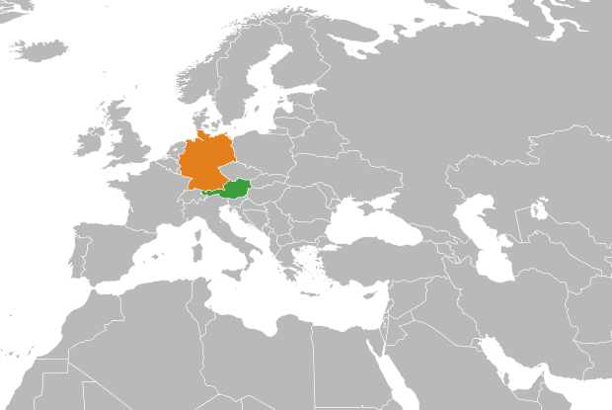

Image 1: “Autogenerated locator map for bilateral relations. Countries are indicated by filename.” Map shows the larger country Germany and Austria below it. Source: Source: https://commons.wikimedia.org/wiki/File:Austria_Germany_Locator.svg
Author: Marmelad. Copyright: May 24, 2008. Attribution: ShareAlike 2.5

Questions:
- BACKGROUND
  - Read: “Totalitarianism in Europe” in “27.1 The Origins of War: Europe, Asia, and the United States in Open Stax.
  - Answer: Reflect on the image above. The large country is Germany and the smaller one is Austria. According to the reading in part a, why did Hitler invade Austria?

- CONSIDER
  - Read: https://courses.lumenlearning.com/suny-hccc-worldhistory2/chapter/the-united-kingdom-and-appeasement/
  - Answer: According to the reading, what is the theory of the policy of appeasement? In what ways did Hitler take advantage of European and American appeasement?

- REFLECT
  - Read: https://www.brookings.edu/blog/order-from-chaos/2020/03/17/crimea-six-years-after-illegal-annexation/
  - Answer: Where is Crimea? According to the reading what was Russia’s justification for annexing it? What does the author suggest, in the second paragraph, when he writes: “But that does not mean the West should accept it.”

- CONNECT
  - Read: This article on Haarertz.
  - Answer: How does the author explain his assertion that Putin is not like Hitler? What does he mean by, “but the echoes are getting louder?” Do you agree or disagree with his conclusions? Why?

