Chapter 30 Roe v. Wade
Christopher Gerdes, M.A.I.S.
Christopher.gerdes@hccs.edu
Directions: Follow each prompt. You will read a selection and/or view an image/document. Answer each question thoroughly. {Instructors: insert specific directions such as word count, response type, submission format, etc.}

- BACKGROUND
- Read: https://www.npr.org/2021/11/29/1056129045/as-the-supreme-court-considers-roe-v-wade-a-look-at-how-abortion-became-legal on National Public Radio.
- Answer: Explain the Roe v. Wade Supreme Court decision.

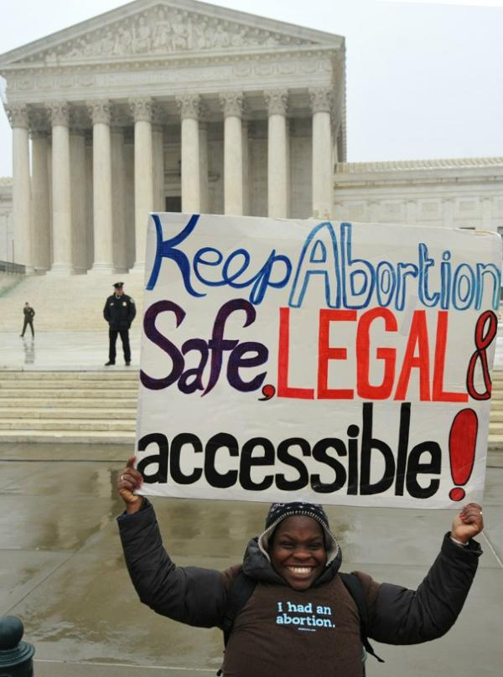
Image 1: “A demonstrator who had an abortion, holds a sign urging lawmakers to keep abortion, safe, legal, and accessible. Date: 27 January 2012. Source: Keep Abortion Sate, Legal & Accessible. Author: Debra Sweet. https://www.flickr.com/photos/worldcantwait/6773079251/. Public Domain.

2. CONSIDER
a. View: Study the image of the woman holding the pro-choice poster above.
b. Answer: What does the message she is conveying indicate about abortions during the pre-Roe v. Wade era?

3. REFLECT
- Read: https://billmoyers.com/2014/07/17/when-southern-baptists-were-pro-choice/
- Answer: What was the view on abortion by Southern Baptists Christians before Roe v. Wade and immediately after the decision? Why do you think evangelicals were not yet uniformly against a woman’s right to abortion?

4. CONNECT
a. Read: https://nlihc.org/resource/point-view-huds-latest-attack-fair-housing
b. Answer: According to the interview on NPR, how did the Republican Party of today become the anti-abortion party?

