Chapter 29 – Hernandez vs. Texas
Christopher Gerdes, M.A.I.S.
Christopher.gerdes@hccs.edu

Directions: Follow each prompt. You will read a selection and/or view an image/document. Answer each question thoroughly. {Instructors: insert specific directions such as word count, response type, submission format, etc.}

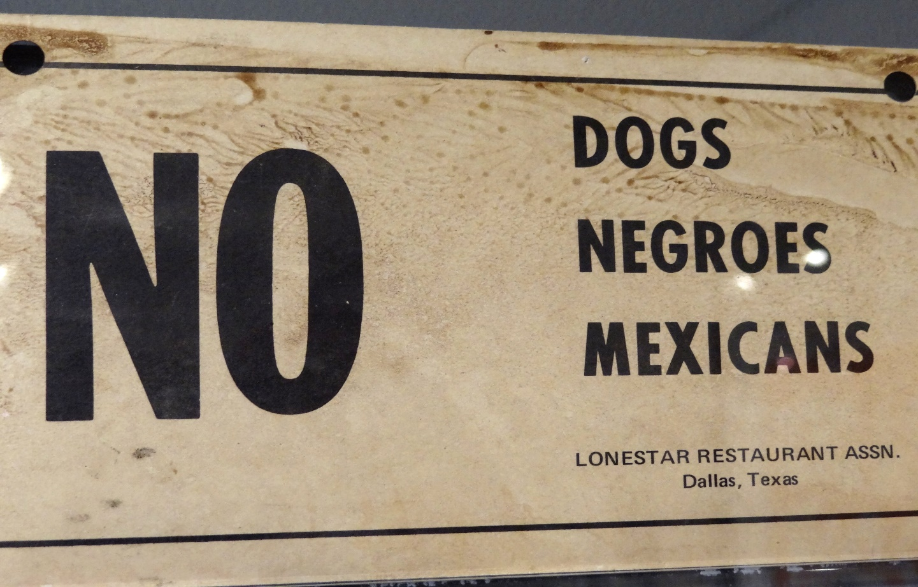
Image 1. The Lonestar Restaurant Association based in Dallas distributed this sign to its members to hang in the windows of their restaurants. "No Dogs, Negroes, Mexicans" sign, Lonestar Restaurant Association, Dallas, Feb 20, 1942. Black History Collection, Manuscript Division, Library of Congress (024.00.00) Public domain.

Questions:
- BACKGROUND
  - Read: “Due Process Clause, Equal Protection Clause and Disenfranchising Felons” from PBS.
  - Answer: Summarize the story told by Sylvia Mendez.

- INTERPRET
  - View: Look at the image above from Dallas, TX
  - Answer: What does it suggest about racial segregation in the south during the 1950’s?

- CONSIDER
  - Read: The Hernandez vs. Texas case in the American Yawp Reader.
  - Answer: Briefly summarize the nature and outcome of this case. How is the 14th used to affect the outcome of this trial?

- CONNECT
  - Read: “Majority of Latinos Say Skin Color Impacts Opportunity in America and Shapes Daily Life” from the Pew Research Center.
  - Answer: Choose one of the findings from the research and explain why you find it interesting. Has the perception that Hispanics in the US have of themselves today changed from the past, in your opinion? Explain.

