Chapter 27 – Zoot Suits
Lauran Kerr-Heraly
Lauran.kerrheraly@hccs.edu

Directions: Follow each prompt. You will read a selection and/or view an image/document. Answer each question thoroughly. {Instructors: insert specific directions such as word count, response type, submission format, etc.}

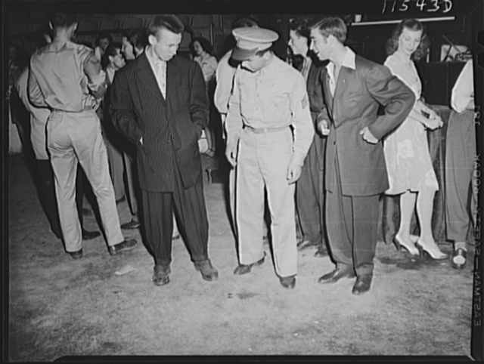

Image: “Soldier inspecting a couple of ‘zoot suits’ at the Uline Arena during Woody Herman’s Orchestra engagement there,” 1942, photography by John Ferrell, https://loc.getarchive.net/media/washington-dc-soldier-inspecting-a-couple-of-zoot-suits-at-the-uline-arena. Public Domain/Creative Commons.

- BACKGROUND
  - Read the article: “Zoot Suit Riots” (Source: Open Stax: 27.2 The Home Front)
  - Discussion Prompt: Why was there such a big increase in immigration from Mexico during World War II?

- CONSIDER
  - View: Study the photo above, taken in 1942.
  - Discussion Prompt: How would you describe zoot suits? What type of men are wearing them in the photo?

- INTERPRET
  - Read the article: “Zoot Suit Riots” (Source: Los Angeles Times)
  - Discussion Prompt: What are some things people remember about the riots?

- CONNECT
  - Read: “School Uniforms and Dress Code Policies Most Likely to Target Females, Latinos and Black Students” (Latin Post)
  - Discussion Prompt: Do you agree that school dress codes target female, Latino, and Black students?

