Chapter 22 -The Big Stick Policy and China’s South China Sea Claim
Christopher Gerdes, M.A.I.S.
Christopher.gerdes@hccs.edu

Directions: Follow each prompt. You will read a selection and/or view an image/document. Answer each question thoroughly. {Instructors: insert specific directions such as word count, response type, submission format, etc.}
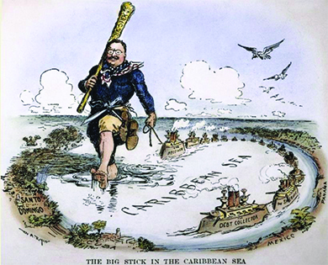
Image 1. “The Big Stick in the Caribbean Sea,” by William Allen Rogers (1854-1931).
Source: https://commons.wikimedia.org/wiki/File:Tr-bigstick-cartoon.JPG.
Copyright, 1904. Source: Public Domain/Creative Commons.

1. BACKGROUND
a. Read: https://openstax.org/books/us-history/pages/22-4-roosevelts-big-stick-foreign-policy#CNX_History_22_04_BigStick in the OpenStax US History textbook.
b. Answer: Explain the meaning of “big stick” foreign policy? According to the reading how did TDR use it to build the Panama Canal?

2. INTERPRET
a. View: Look at the image above.
b. Answer: Describe how the details reflect the Big Stick Policy.

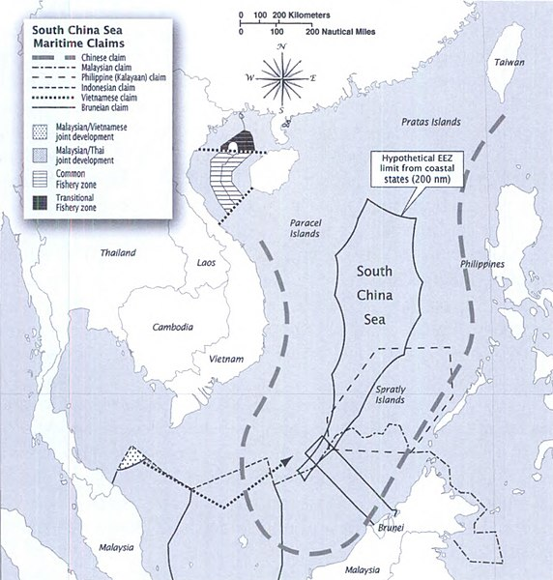
Image 2. “South China Sea Maritime Claims,” by The National Defense University Press (2011).

Source: https://commons.wikimedia.org/wiki/File:South_China_Sea_Maritime_Claims.jpg.
Public Domain.

3. CONSIDER
a. Read: Read the article, “A Primer On The Complicated Battle For The South China Sea, ” by Rami Ayyub of National Public Radio.
a. Answer: What is the conflict about and what are the competing claims being made by various nations in the region?

4. CONNECT
a. View: Study the map above depicting the Nine-Dash Line.
b. Answer: Considering the map above and the reading in part 3, make a comparison between China’s South China Sea claim and TDR’s Bick Stick Policy at the beginning of the 20th century.

