Chapter 22 – American Imperialism
Christopher Gerdes, M.A.I.S.
Christopher.gerdes@hccs.edu

Directions: Follow each prompt. You will read a selection and/or view an image/document. Answer each question thoroughly. {Instructors: insert specific directions such as word count, response type, submission format, etc.}
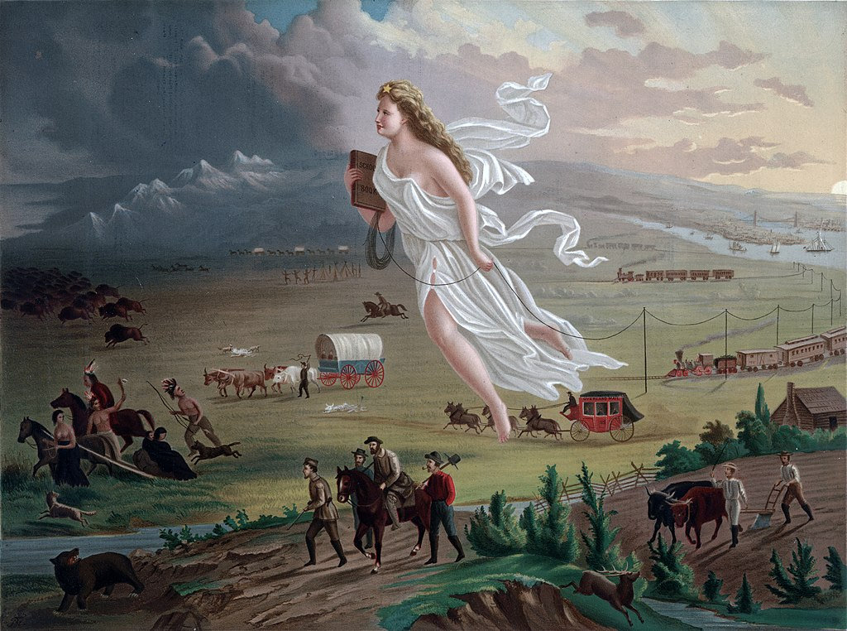
Image 1. “American Progress.” Print shows an allegorical female figure of America leading pioneers westward, as they travel on foot, in a stagecoach, conestoga wagon, and by railroads, where they encounter Native Americans and herds of bison.
Copyright by George A. Crofutt. After 1872 painting of the same title by John Gast. Source:
https://www.loc.gov/resource/ppmsca.09855/. Library of Congress. Public Domain.

- BACKGROUND
  - Read: https://openstax.org/books/us-history/pages/17-1-the-westward-spirit in the OpenStax US History textbook.
  - Answer: Describe the westward spirit.

- CONSIDER
  - Watch: The Age of Empire from Khan Academy which gives background to the Age of Imperialism: https://www.youtube.com/watch?v=eJgtqs_Rwts
  - Answer: What two reasons does Kim explain are the motivation for imperialism? According to Kim, what does Frederick Jackson Turner say is so troubling for Americans?
- INTERPRET
  - View: John Gast painted the above illustration in 1872.
  - Answer: List and explain at least three details in the painting that illustrate Manifest Destiny.

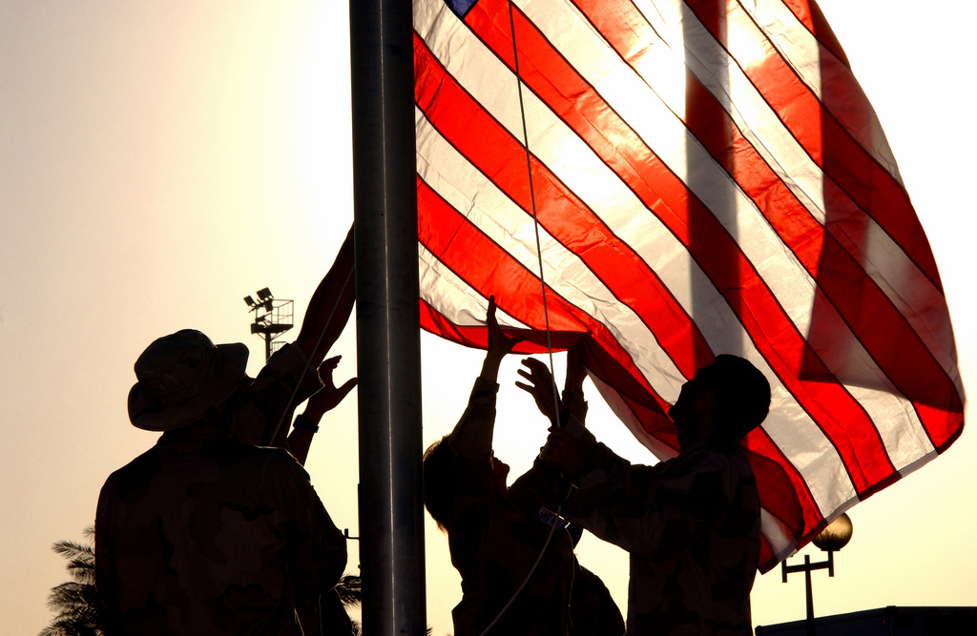
Image 2. At the Baghdad (Iraq) International Airport (BIA), Baghdad, Iraq, US Air Force (USAF) personnel from the 447th Air Expeditionary Group (AEG) Command STAFF raise an American flag during a memorial service dedicated to those who lost their lives September 11th, 2001
Copyright Summary: 11-9-2003 by Scene Camera Operator: A1C Brian Ferguson, USAF.
Subject Operation/Series: IRAQI FREEDOM, Base: Baghdad International Airport
Country: Iraq (IRQ). Scene Major Command Shown: USCENTAF.
Release Status: Released to Public
Combined Military Service Digital Photographic Files
Source: https://picryl.com/media/at-the-baghdad-international-airport-bia-baghdad-iraq-us-air-force-usaf-personnel-11cb2d. The US National Archives. No known copyright restrictions.

4. CONNECT
  - View: Look at the photograph above of soldiers raising the American flag at the airport in Baghdad, Iraq about 8 months after the U.S. invasion of Iraq.
  - Considering the theme of Manifest Destiny, is it possible to connect the dots from the first image to the events of the second one much later in American history? Why of why not?

