Chapter 20 – Politics and Corruption During the Gilded Age
Christopher Gerdes, M.A.I.S.
Christopher.gerdes@hccs.edu

Follow each prompt. You will read a selection and/or view an image/document. Answer each question thoroughly. {Instructors: insert specific directions such as word count, response type, submission format, etc.}
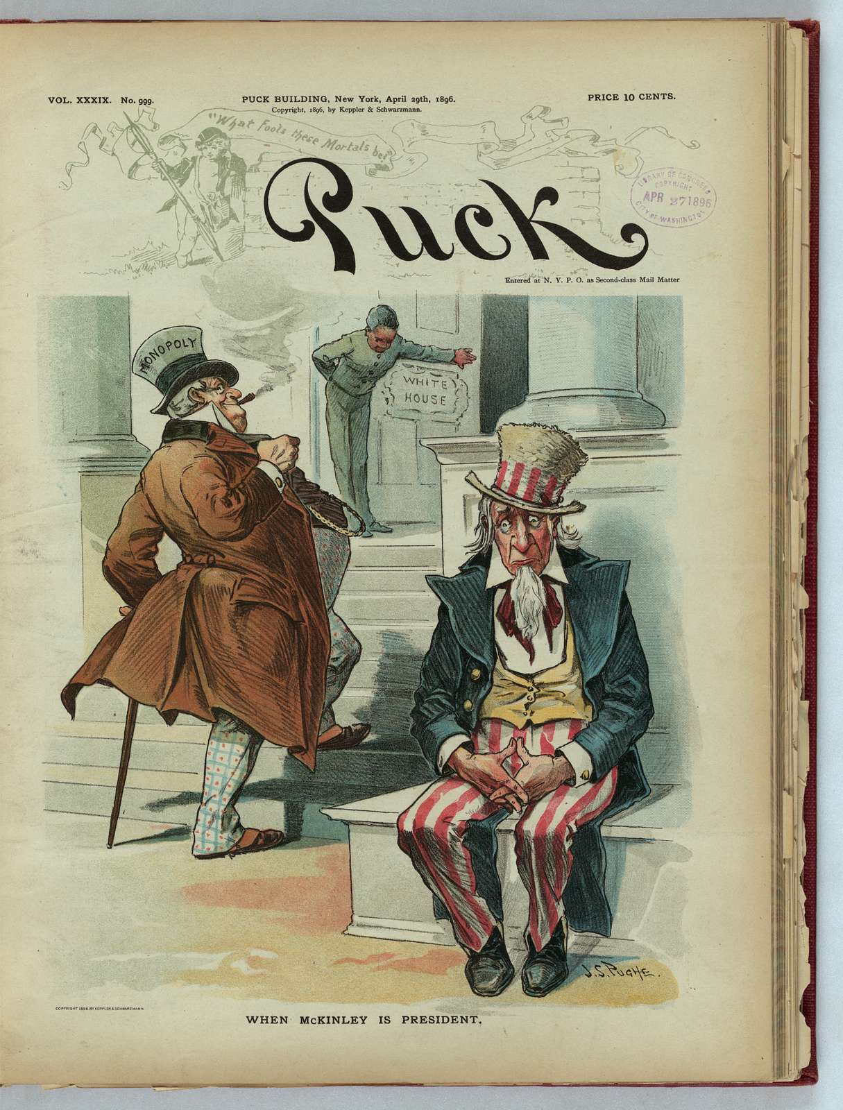

Image 1. “When McKinley is President.” Print shows Uncle Sam sitting on the steps to the White House as a man (McKinley) wearing a top hat labeled "Monopoly" walks up the steps to enter the White House. by Pughe, J. S. (John S.), 1870-1909, artist. Illus. from Puck, v. 39, no. 999, (1896 April 29), cover.

Copyright 1896 by Keppler & Schwarzmann. Source: https://picryl.com/media/when-mckinley-is-president-js-pughe. Library of Congress. No Known restrictions on publication.

- BACKGROUND
- Read: Figure 20.3 https://openstax.org/books/us-history/pages/20-1-political-corruption-in-postbellum-america#Figure_20_01_GildedAge in the OpenStax US History textbook.
- Answer: How does the reading reflect what Mark Twain calls “The Gilded Age.?”

- CONSIDER
a. View: Study the political cartoon above.
b. Answer: Describe how the image reflects “The Gilded Age?”

3. REFLECT
a. Read: https://ohiohistorycentral.org/w/Teapot_Dome_Scandal
b. Answer: What crime was the 1920’s President Warring G. Harding’s Secretary of Interior Albert Bacon Fall accused of? How were his actions representative of the Gilded Age?

4. CONNECT
a. Read: Thomas T. Holyoke and Timothy M. LaPira, “Lobbying is Growing in the US- More Information May be the Best Regulation,” USAA -United States Politics and Society, Oct., 2017, https://blogs.lse.ac.uk/usappblog/2017/10/11/lobbying-is-growing-in-the-us-more-information-may-be-the-best-regulation/
b. Answer: According to the article, what is the role of lobbyists in American politics today? What is the criticism? How is this form of political corruption similar to, or different than that of The Gilded Age?

