Chapter 20 – Presidential Assassinations and Reform
Christopher Gerdes, M.A.I.S.
Christopher.gerdes@hccs.edu

Directions: Follow each prompt. You will read a selection and/or view an image/document. Answer each question thoroughly. {Instructors: insert specific directions such as word count, response type, submission format, etc.}

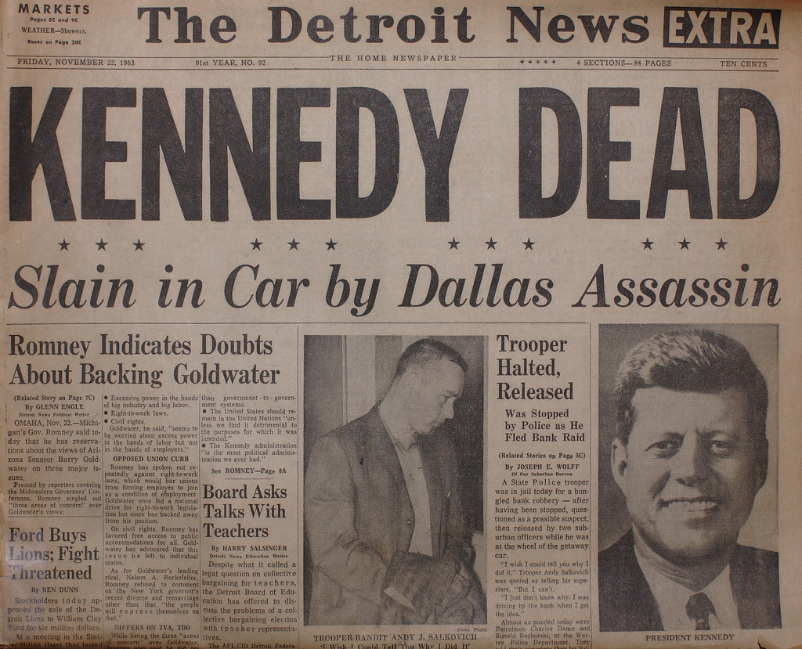

Image 1. “Kennedy Assassination” by Detroit News. Copyright Nov. 22, 1963. Source: https://www.flickr.com/photos/rtdphotography/3214792726. Creative Commons: Public Domain

- BACKGROUND
a. Read: https://courses.lumenlearning.com/boundless-ushistory/chapter/the-jackson-administration/ in Lumen Learning.
b. What is patronage, also known as the “spoils system,” and which president is credited with formalizing it?

2. CONSIDER
a. Read: https://www.smithsonianmag.com/history/garfield-assassination-altered- american-history-woefully-forgotten-today-180968319/
b. Answer: Sometimes after political assassinations the public and political mood of the country pushes political reform. How did the assassination of President Garfield lead to the creation of the Pendleton Act?

3. REFLECT
a. View: Look at the image above.
b. Answer: What about this headline suggests an event of great importance? From what you understand or have learned, how did the American public generally respond to Kennedy’s assassination?

4. CONNECT
a. Read: https://www.theguardian.com/world/2013/nov/19/john-f-kennedy-assassination-racial-equality-jfk
b. Answer: According to the article, how did the Kennedy assassination spur “the drive for racial equality?” What other events in the nation, besides political assassinations, have spawned social or political change in more recent times?

