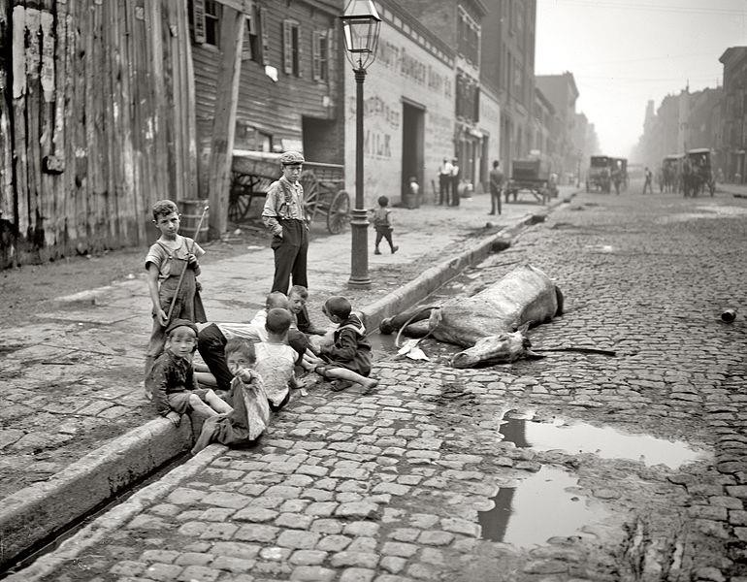
Image 1. Detroit Publishing Co., Publisher, Byron, photographer. The close of a career in New York. United States New York New York State, None. [Between 1900 and 1906] Photograph. https://www.loc.gov/item/2016794664/. Public domain/No known restrictions on publication

BACKGROUND:

  - Read: About the Gilded Age: https://openstax.org/books/us-history/pages/20-1-political-corruption-in-postbellum-america in the OpenStax US History textbook.
  - Answer: What does Mark Twain mean when he refers to the “Gilded Age?”

2. CONSIDER
a. View: Carefully study this 1905 image of a street in New York City.

b. Answer: How does it reflect what Mark Twain is referring to? What kind of social and economic challenges does it suggest are happening during this time?

3. REFLECT

  - View: Study the following graph of historic inequality in America: https://public.tableau.com/app/profile/ips.inequality/viz/AmericanHasBecomeStarklyMoreUnequal/Dashboard1
  - Answer: The graph shows how the income of America’s top .1% has changes following the post Gilded Age era until recent years. What does is suggest about income inequality?

4. CONNECT

  - View: https://inequality.org/great-divide/america-2018-more-gilded-america-1918/
  - Answer: According to the article, how does inequality today compare with the Gilded Age? What social value about these circumstances does the author suggest in the last sentence?

