Chapter 18 – Social Change and Women in the Late 19th Century
Christopher Gerdes, M.A.I.S.
Christopher.gerdes@hccs.edu

Directions: Follow each prompt. You will read a selection and/or view an image/document. Answer each question thoroughly. {Instructors: insert specific directions such as word count, response type, submission format, etc.}
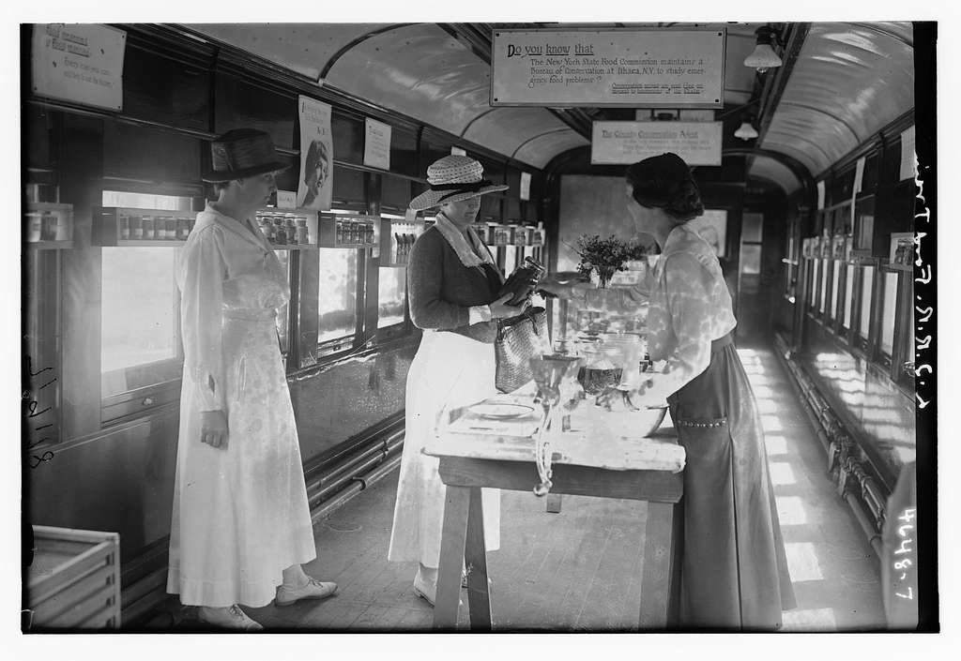
Image 1. “L.I.R.R. Food Train.” Photograph shows the Long Island Railroad "Victory Special" demonstration car, organized by the women of the Long Island Food Reserve Battalion during World War I. Copyright 01/01/1918.
Source: https://picryl.com/media/lirr-food-train-c14dcc. Library of Congress, Prints & Photographs Division (Part of the George Grantham Bain Collection). Public Domain.

- BACKGROUND
a. Read: https://www.coursehero.com/study-guides/atd-fscj-ushistory2/industrialization-and-the-gilded-age/ in Lumen Learning.
b. Answer: How did the Second Industrial Revolution change the role(s) of women in America?

2. CONSIDER
a. View: Look at the image above.
b. Answer: How does the image reflect the changing expectations of women from this time period?

3. REFLECT
a. Investigate: Research the definition of the term “revolution.” In the context of this prompt, it should refer to the social changes that took place in America during the Second Industrial Revolution.
b. Answer: Write down the definition you chose? Why did you choose the one you did?

4. CONNECT
a. Read: Scroll through the following reading and look for evidence of how changes in social media technology reflect the definition of “revolution.” https://press.rebus.community/mscy/chapter/chapter-2-digital-culture/
b. Answer: How does social media technology represent a revolution in our age? How does this kind of revolution compare to that discussed in parts 1-3?

