Chapter 18 – Gospel of Wealth
Christopher Gerdes, M.A.I.S.
Christopher.gerdes@hccs.edu

Directions: Follow each prompt. You will read a selection and/or view an image/document. Answer each question thoroughly. {Instructors: insert specific directions such as word count, response type, submission format, etc.}
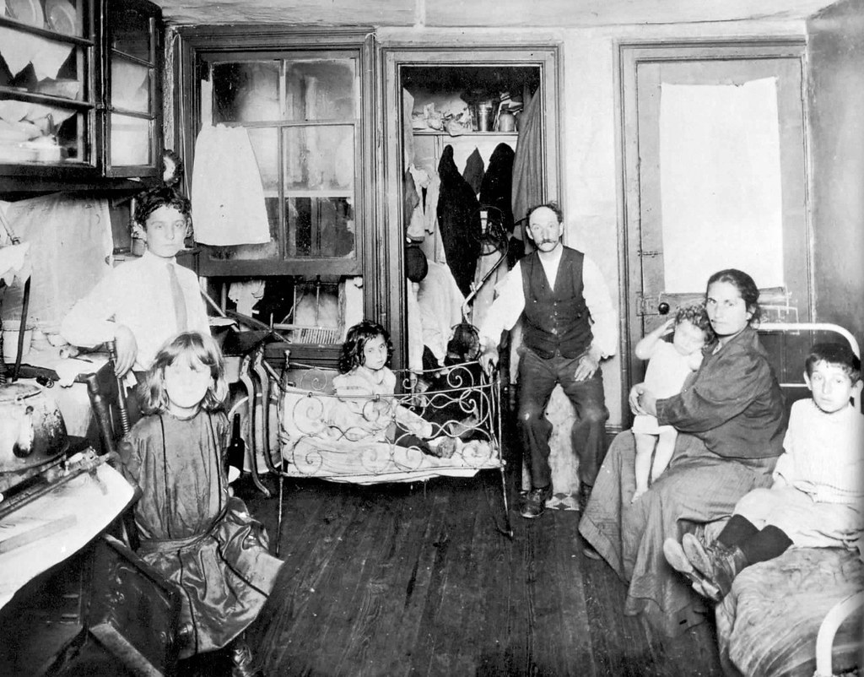
Image 1: “Five Cent a Shot,” Unauthorized Lodging in a Byard Street Tenement. By Jacob Riis. Collections: Jacob August Riis Photography in How the Other Half Lives: Studies Among the Tenements of New York. c. 1890. Source: Preus Museum. Source link https://picryl.com/media/five-cent-a-spot-unauthorized-lodgings-in-a-bayard-street-tenement-32c269. Public Domain. No known restrictions on publication.

Questions:
1. BACKGROUND:

a. Read: “Pioneering Social Reformer Jacob Riis Revealed “How The Other Half Lives” in America” in The Smithsonian Magazine.
b. Answer: How does Jacob Riis connect wealth and poverty to the role of early philanthropy?

2. CONSIDER:
a. View: Look at the photo above taken in 1890 taken by Jacob Riis of an occupied tenement in New York City
b. Answer: What does this photo suggest about life in urban New York City?

3. REFLECT:
a. Read: The Gospel of Wealth by Andrew Carnegie on the Carnegie foundation website
b. Answer: What does Carnegie mean by “proper administration of wealth?” In which ways does he suggest wealth could be distributed in society, and which one does he agree with most? Why? Is his message consistent with that of Riis?

4. CONNECT:
a. Read: Explore the Bill and Melinda Gates Foundation.
b. Answer: Explain, according to the website, the role of the foundation. How has the ideal of philanthropy changed over the last century?

