Chapter 17 – Immigration Experience
Christopher Gerdes, M.A.I.S.
Christopher.gerdes@hccs.edu
Directions: Follow each prompt. You will read a selection and/or view an image/document. Answer each question thoroughly. {Instructors: insert specific directions such as word count, response type, submission format, etc.}
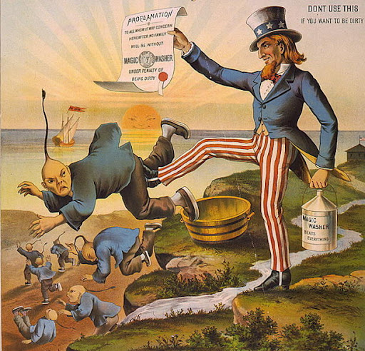

Image 1. “The Chinese Must Go – Magic Washer." Anti-Chinese Immigrant US
Cartoon by The George D. Magic Washing Company. Copyright 1886. Source: Commons.wikapedia.org. Public domain/Creative Commons.

- BACKGROUND
  - Read: https://openstax.org/books/us-history/pages/17-5-the-impact-of-expansion-on-chinese-immigrants-and-hispanic-citizens (Section 17.5) in the OpenStax US History textbook.
  - Answer: According to the chapter reading, what factors led to anti-Chinese sentiment in America and the eventual Chinese Exclusion Act of 1882? List and explain at least three.

- CONSIDER
  - View: Study the political cartoon above carefully.
  - Answer: Describe the anti-Chinese sentiment expressed in this late 19th Century political cartoon?

- REFLECT
  - Read: “The Transcontinental Railroad and the Asian Story”
  - Answer: What does the site celebrate, and what, if any, does it condemn?

- CONNECT
  - Read: https://ballotpedia.org/California_Proposition_187,_Prohibit_Undocumented_Immigrants_from_Using_Public_Healthcare,_Schools,_and_Social_Services_Initiative_(1994)
  - Answer: What was California’s Proposition 187? Compare the Proposition 187 initiative to the anti-Chinese sentiment of 1882.

